**MY PROJECTS**

**STUDENT NAME:** AGNIV PRAMANICK

**USN:** 1NT21IS017

**BRANCH:** INFORMATION SCIENCE AND ENGINEERING

**SEMESTER:** 4

1. **CUSTOM GOOGLE POSTER**

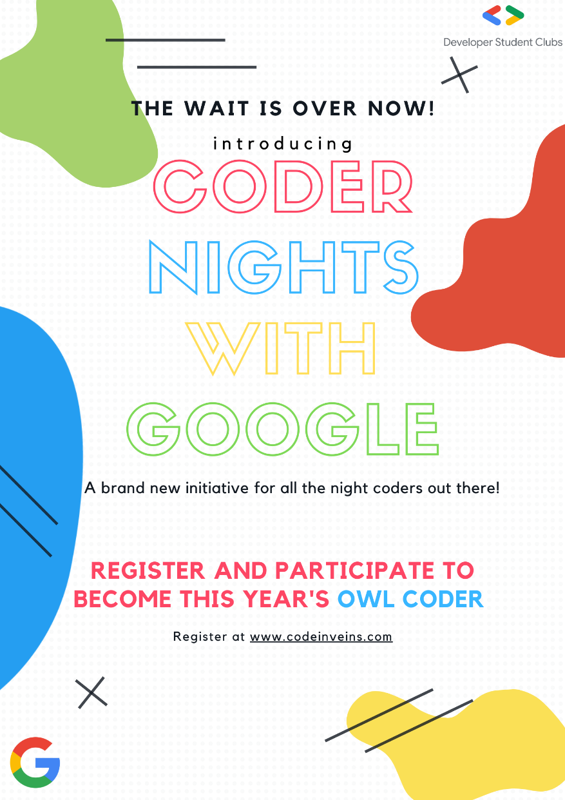

1. **FACEBOOK COVER** 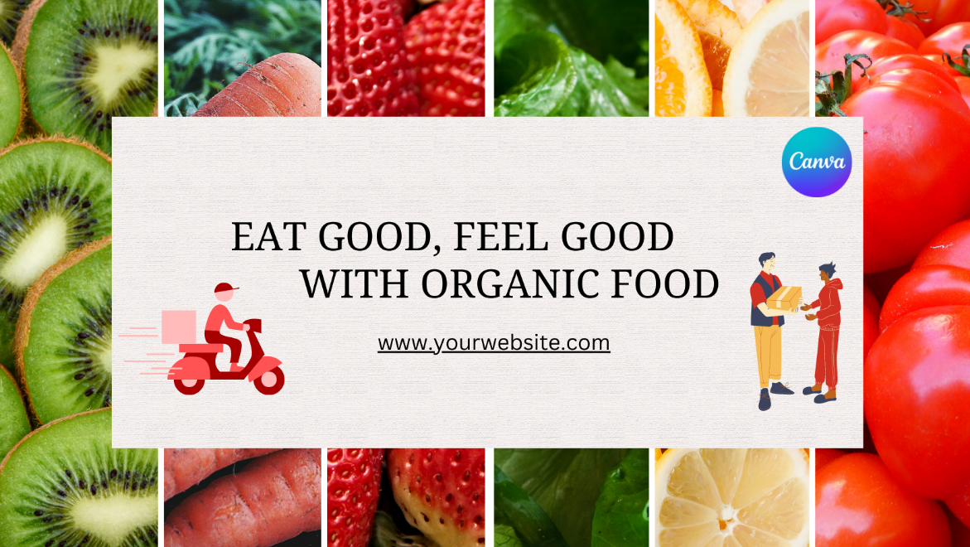
2. **FACEBOOK POST**



1. **SAMPLE TWITTER HEADER**

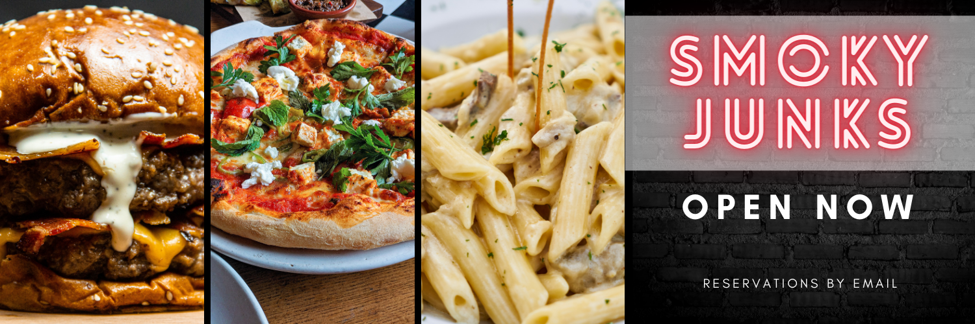

1. **YOUTUBE CHANNEL ART**

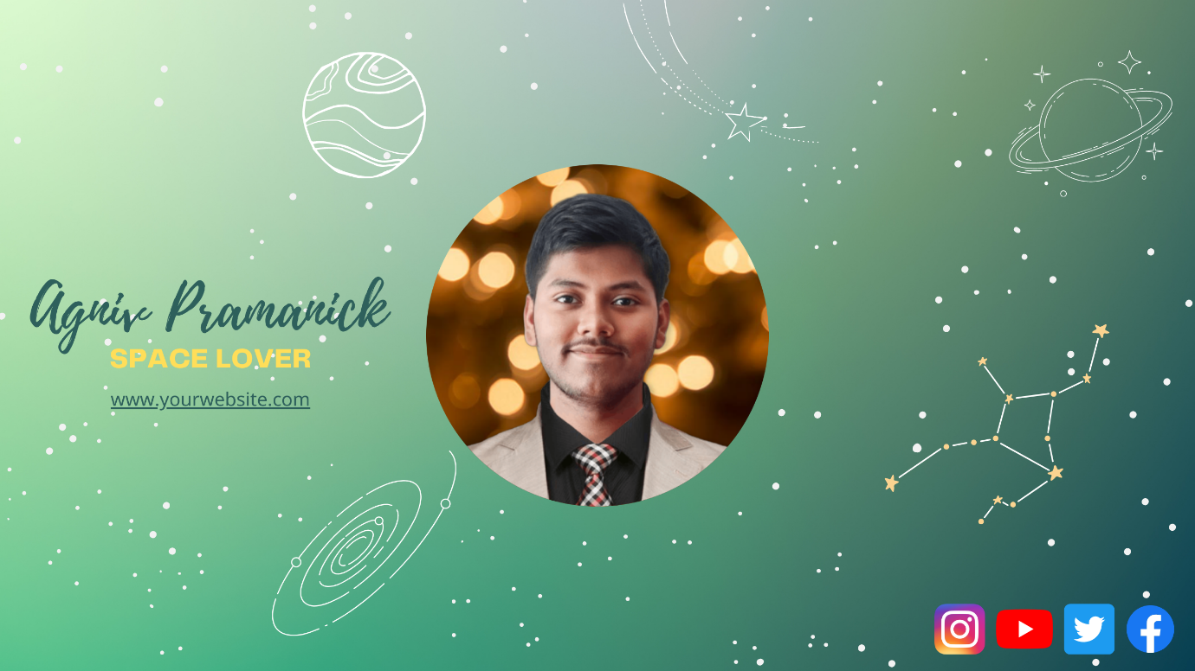

1. **INSTAGRAM POST**



1. **IEEE POSTER FOR UPCOMING TALK** (I AM A MEMBER OF IEEE, AND I WAS GIVEN THIS TASK TO DO SO).

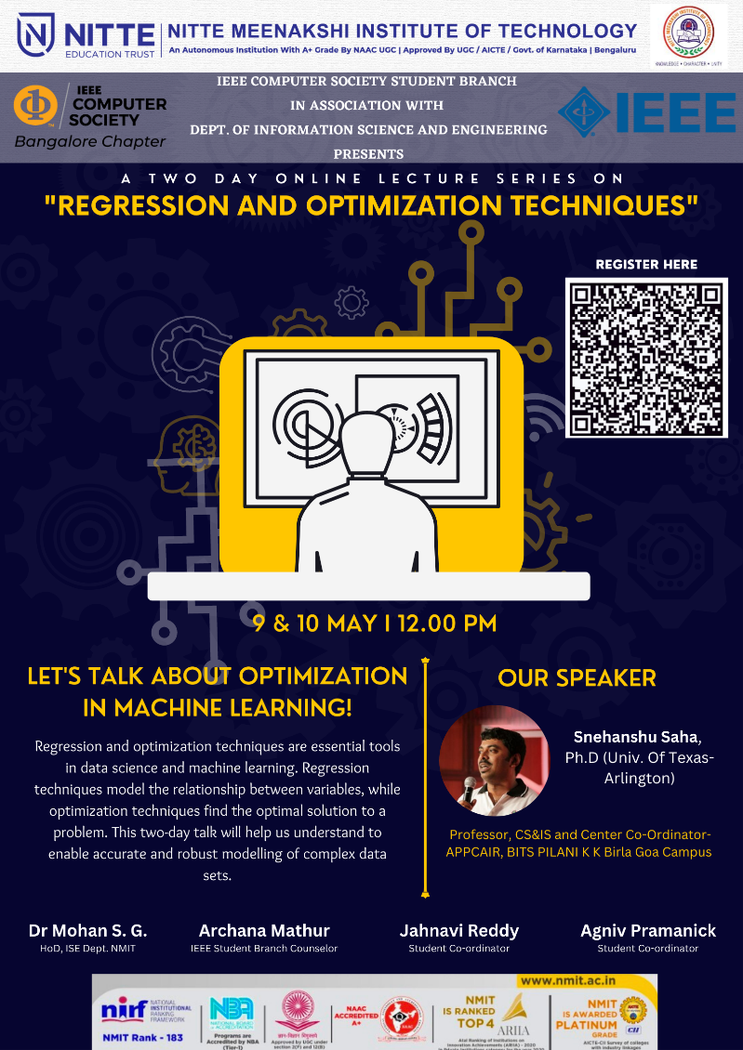

1. **YOUTUBE THUMBNAIL**

**LINK:**

<https://www.canva.com/design/DAFiHSku0rg/De8OODn6ma462fzRhi-gDw/edit?utm_content=DAFiHSku0rg&utm_campaign=designshare&utm_medium=link2&utm_source=sharebutton>

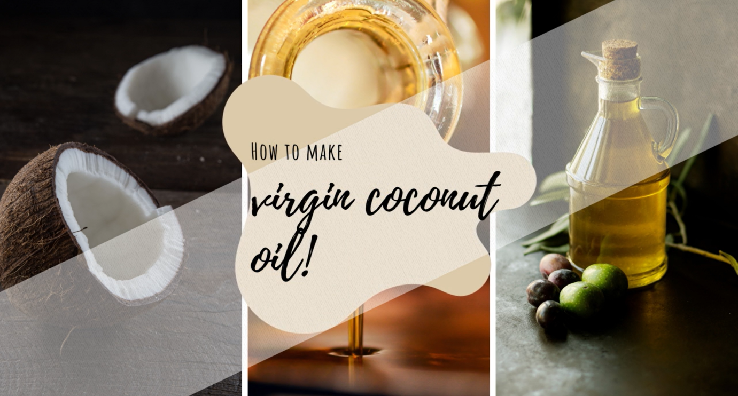

1. **WEBSITE DESIGN USING FIGMA**

**LINK:**

<https://www.figma.com/file/9Lk8KJUiwp1uZoh5gZWe0c/OUR-WEBSITE-DESIGN-FINAL?type=design&node-id=6%3A28&t=2LSaDgnZEK0YgUAC-1>

**SCREENSHOTS:**

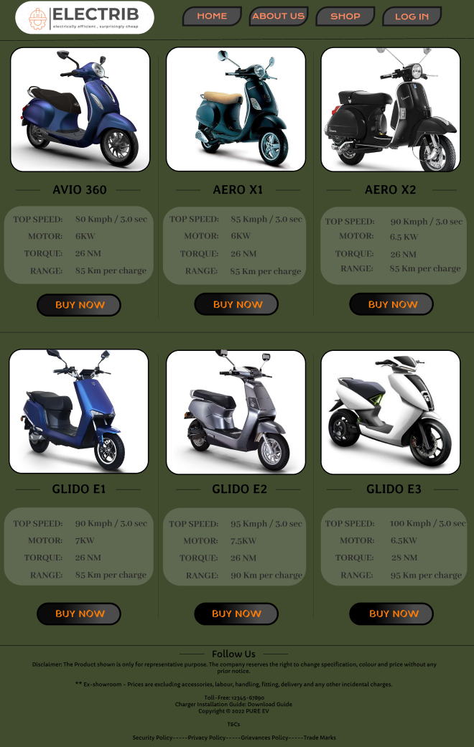**SHOP PAGE**

**ABOUT US PAGE**

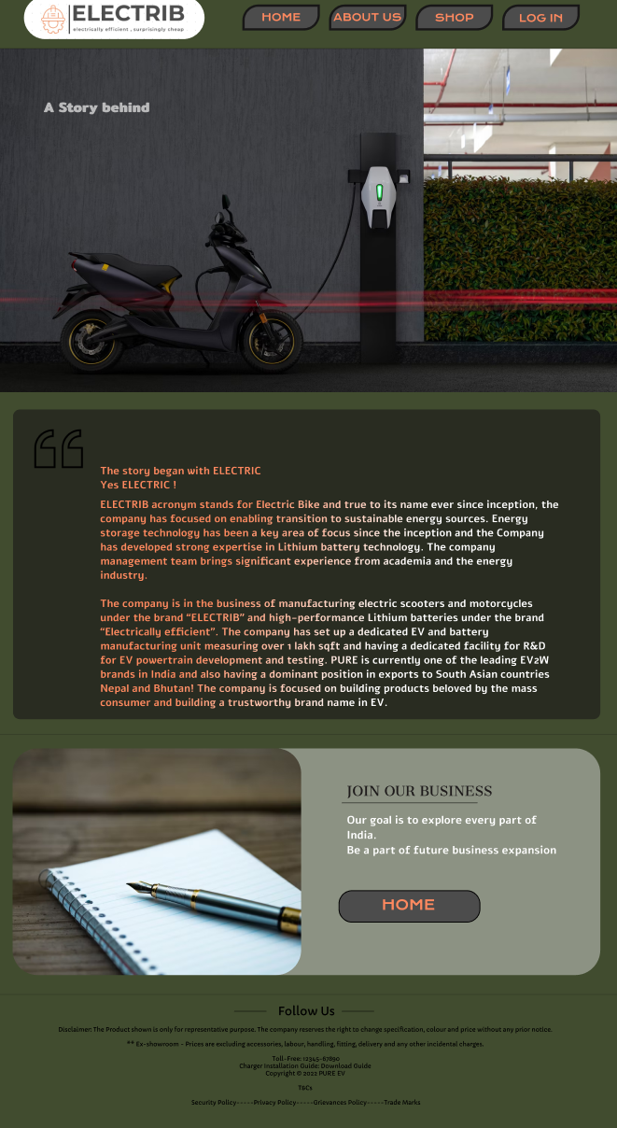**\\**

**LOGIN/ SIGN UP PAGE**

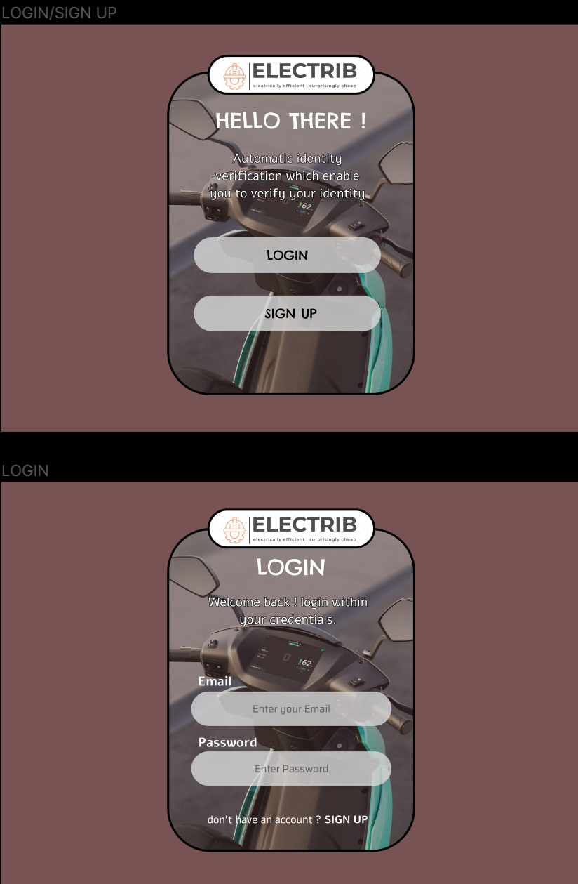

**HOME PAGE**

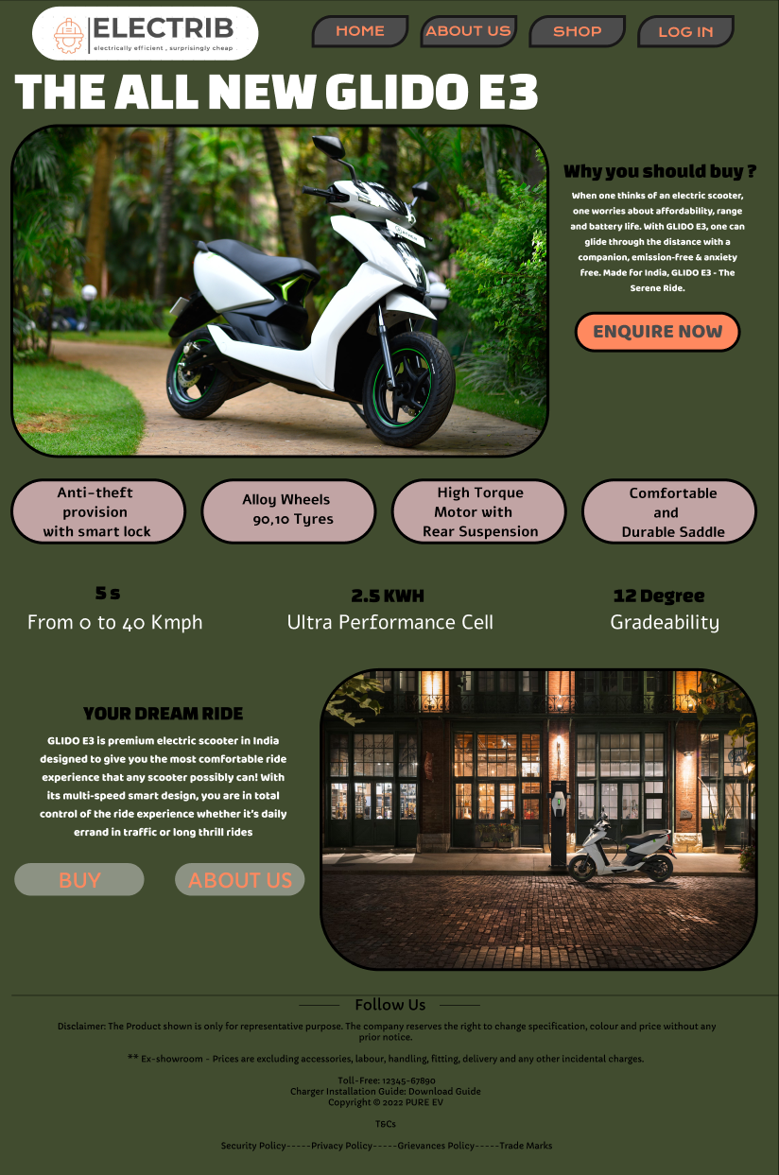

1. **ANIMATED SOCIAL MEDIA DEMO**

**LINK:**

<https://www.canva.com/design/DAFHbtuBpAM/ryScbc03Pw9U31uE25szUg/edit?utm_content=DAFHbtuBpAM&utm_campaign=designshare&utm_medium=link2&utm_source=sharebutton>